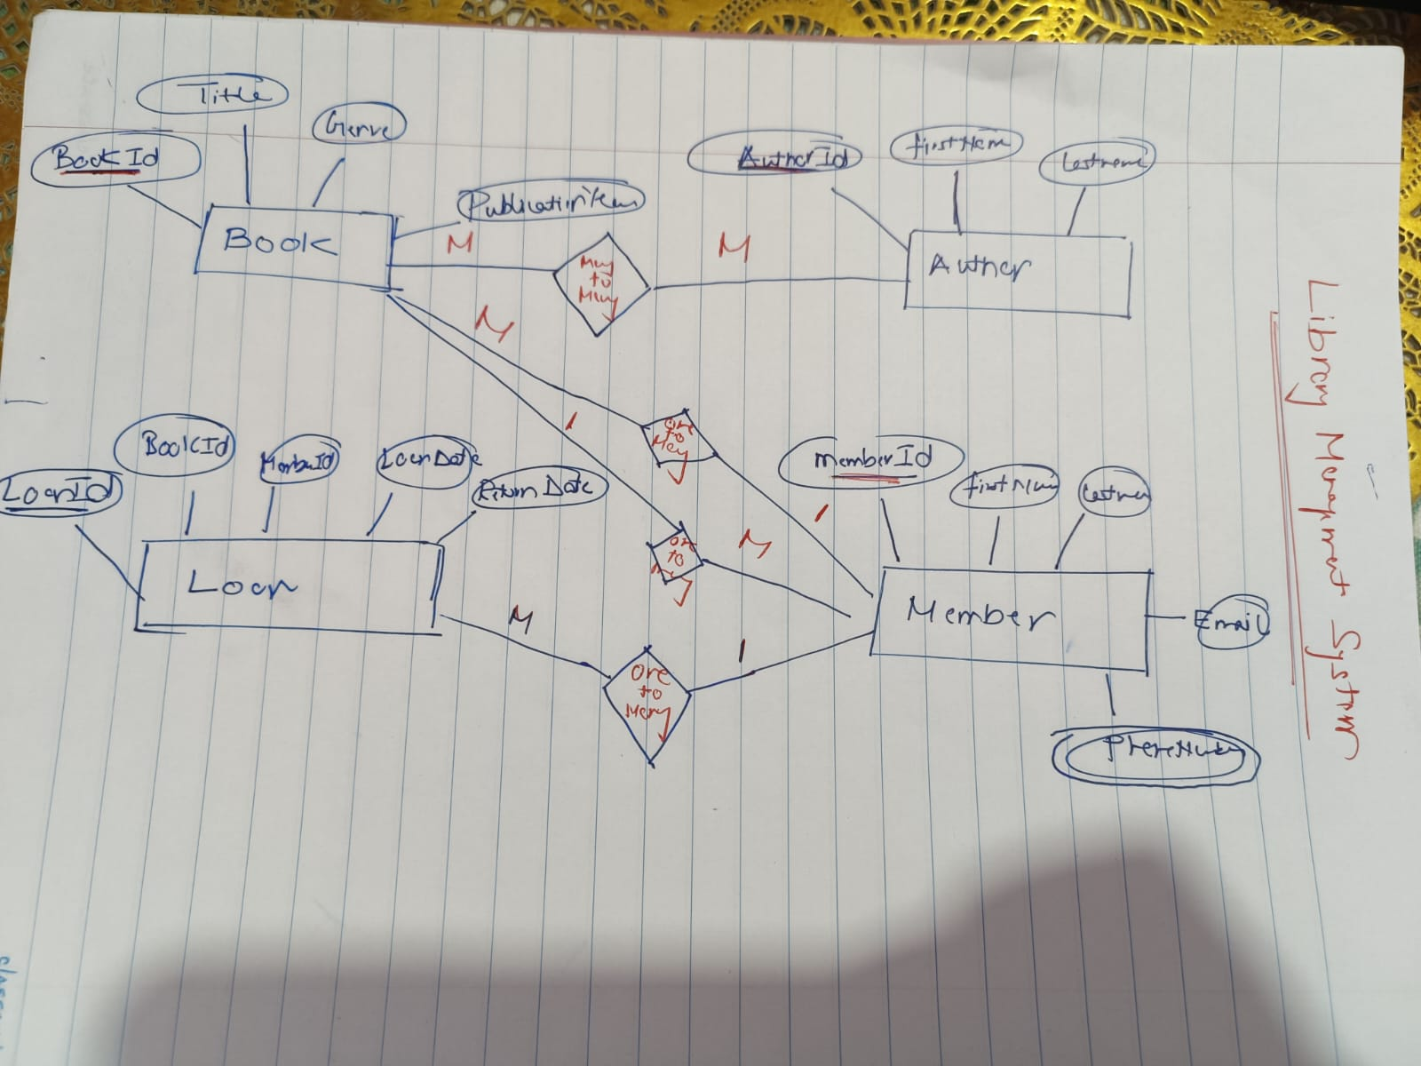

**Relations**

1. **Books and Author (Many-to-Many)**

A single book can be authored by multiple authors and an individual author can write many books.

1. **Books to Loans (One-to-Many)**

Each book can be loaned out multiple times to different members or same members but each loans refer to that specific book.

1. **Members to Loans(One to many)**

A member can borrow multiple books over time that results in multiple loan records. But each loan is associated to that specific member.

**4)Members to Books(One-to-many and Many-to-one)**

A single member can borrow multiple books and a single book can be borrowed by multiple members.

So I can say relation is also Many-to-many.